Soft Systems Analysis: Improving the UK Passport System

Name:
Professor:
Course:
Date:

INTRODUCTION
Overview of the Situation
Improving any information technology (IT) system today is one of the most complex projects that organizations engage in today. Adoption of new changes in the IT departments in organizations is faced by challenges like lack of a clear scope, poor leadership, lack of motivation, and poor communication (Princewill, 2019). An excellent example of an IT problem occurred during the improvement of the UK passport system in the 1990s and in the 21st century. The system needs to be improved to ensure that it offers British citizens with passports. In the 1990s, the agency planned to improve the existing system to a more digitized one, which would seamlessly provide UK citizens with passports economically and promptly. In 1996, the introduction of a digital system to minimize fraudulent use of passports was initiated. However, due to poor planning, the intended digital transformation was not successful. Inadequate staff training also affected their ability to adopt the new system on time. Ineffective adoption of the new system led to increased passport processing time. These challenges were expensive for the agency and the private firms given the contract to transform the system. Changing policies of passport issuance was another factor that made the change hardly realized. There was limited communication to the public regarding the transformations that were taking place and how they would affect Britons. With plans to transform the system into a fully digital system, it is necessary to reflect on the factors that affected a successful transformation in the late 20th century. Having a contingency plan and testing the system before rolling it for the public system is critical because they will determine the system's success.
Rich Picture
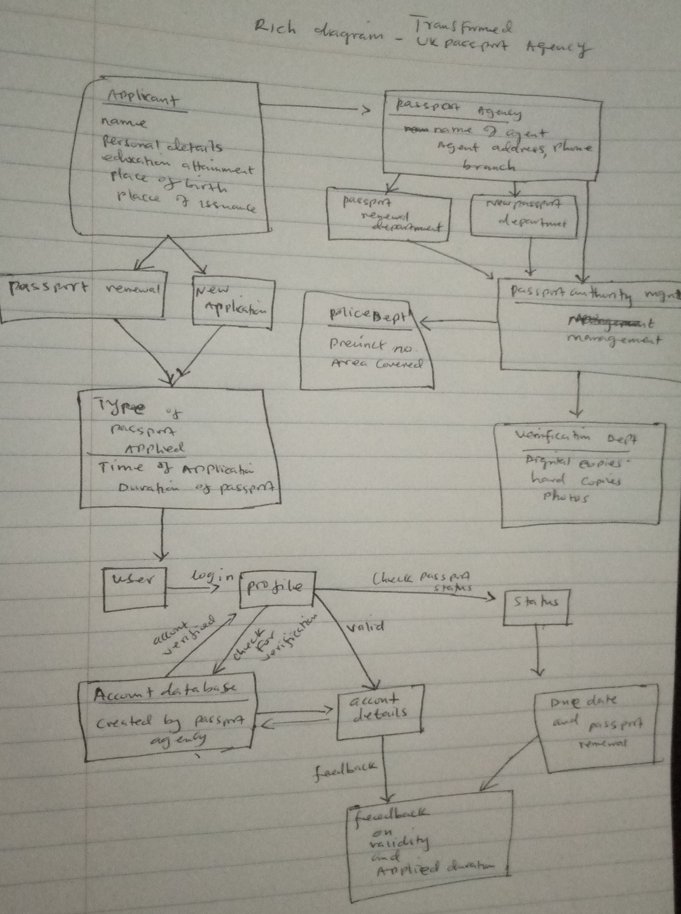
Client and Problem Owner
Different clients were affected by problems experienced by the Passport Agency. Among the affected clients were children who were not included in their parents’ passports during the 1998 system transformations, more than 500,000 British citizens whose passports were delayed, staff members in the Agency who had to work overtime and in different environments.
In 1998, the Agency passed new legislation that children who were not covered by their parents' passports would need to apply for new passports. This was a major issue considering that the legislation was implemented at the same time when a new system was introduced. With an increased demand for new passports, the new system would end up being overwhelmed. This problem was caused by the Agency’s poor planning in the area of legislation implementation and system introduction. Lack of effective communication between different departments in the agency can be linked to the problem. In this case, it can be seen that the ICT department rolled out a new system at the same time when the legal department passed a new law. Lack of departmental communication led to the inability of the new system to process passports to cover the increased level of demand. Therefore, the Agency’s failure to properly coordinate projects within its departments led to the problem of increased children passport demand, which was hardly met by the new system. The reason for choosing this client is because children are depended on their parents, and thus there was no need to pass a new law that would significantly inhibit the performance and productivity of the transformed IT system.
SYSTEM IDENTIFICATION AND DESCRIPTION
Primary Tasks and Current Issues
The new fully digital system will enhance the ability of the Passports Agency to serve millions of British citizens across the world. The new system will have different primary tasks, including an online application, minimizing application errors associated with the use of paper copies, issuance of passports without human intervention, improved fraud detection and public protection performance, communicating with customers and keeping them updated throughout their engagement, enhance facial matching and data verification. There are current issues that the system is facing. These can include use of a highly linear and manual system, use of paper-based communication, high IT costs due to poor integration, limited communication with customers, poor fraud detection and public performance protection.
The primary task that this paper will address further is the improvement fraud detection and public protection performance. Exploring this task is important because currently the system is expected to serve millions of Britons. Therefore, it is necessary to develop a system that has effective and efficient performance capabilities. The use of data analytics will play an essential role to help in the analysis of customer information. According to Ogrean (2019), data analytics helps improve the efficiency of an organization because there is constant surveillance of employees to determine their performances as well as that of the business. Data analytics helps understand markets better. With vast volumes of data being available, technologies have been developed to help collect and analyze data easily. Through data mining, organizations can understand consumer behaviours and needs, thus helping them improve their marketing strategies. This concept helps business leaders to make informed decisions. Other roles include cost reduction, understanding market trends, and the development of quality products and services that address the needs of consumers (Ogrean, 2019). Data analytics is performed by gathering data and grouping it based on similarities and differences. Different groups of data make it easier for data analysts to identify trends, similarities, and differences in data sets.
The issue that I will focus on is poor fraud detection and public performance detection. This issue is linked to the primary task addressed above. By addressing this issue, the system can optimally serve British citizens equally and effectively.
Relevant Systems
The system will be designed to analyze customer information using data analytics, ensuring that the right information is presented at all times. To address the current issue, the system will be equipped with data analytics technologies, which can efficiently sift through structured, semi-structured, and unstructured customer data.
CATWOE and Root Definition
The system that I have chosen to work within this case is the one addressing the primary task. The customers who will benefit from this system are British citizens applying for new passports of going for passport renewal. This system will improve their ability to apply for passports without the fear of fraud and poor system performance. Also, the system will ensure that examiners in the Agency identity people who provide fake information. Therefore, transparency and efficiency will be established in the Agency. Different actors will be involved in this system. Data analysts and examiners in the Passport Agency will be the key actors in this system. Data analysts will be responsible for analyzing large volumes of data presented by customers who are applying for new passports or coming for renewal. Analysts will rely on technologies like NoSQL, predictive analytics, and knowledge discovery tools. These technologies will enable data analysts to make informed decisions and be prepared for different scenarios, manage data across several storage nodes, and mine big data in multiple sources. Examiners, on the other hand, will be responsible for examining samples of analyzed data to determine if the results are accurate and compliant to the Agency policies. The transformation will improve the authenticity of the passport issuance process and ensure that public service provisions to British citizens are enhanced. The transformation will also ensure that fraud detection is effective, allowing for eligible applicants to apply or renew their passports. The wide picture of this system is to be able to offer excellent passport issuance services to all British citizens across the world. The people responsible for any problem that may arise within the system are the Director-General of HMPO and staff members. Different constraints can affect the implementation of the proposed solution in case of challenges arising. Licensing laws, Home Office regulations, a threat to civil rights and privacy, and lack of reliability in the system.

MODELLING AND ACTIONS FOR THE FUTURE
Conceptual Model
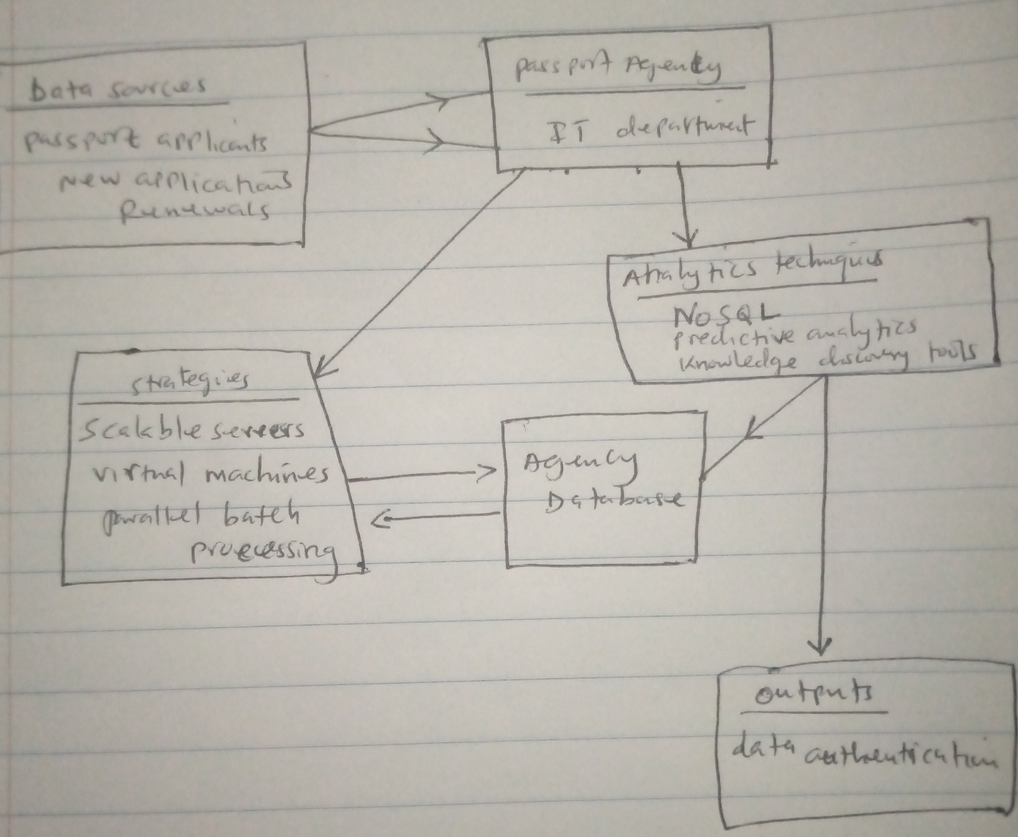
This system will be designed to analyze the authenticity of data provided by customers. Data gathered from millions of British citizens will be collected by staff members working in the Agency’s IT department. After collection, this data will be sorted based on three strategies; that is, using scalable servers, virtual machines, and parallel processing. These three strategies will be essential in the categorization of data (structured, semi-structured, and unstructured data). Three data analytics technologies will be used in this system. The system will use NoSQL to help in data management, the use of predictive analytics to help in decision-making and development of contingency plans, and use knowledge discovery tools to aid in big data mining from different sources. This system will be verified through program derivation. An efficient code will be derived based on the functional specifications of the system. This approach will determine whether the system is correct based on the construction adopted. The Bird-Meertens formalism will be used to derive the program using mathematical models to prove its operability (Ray, 2010). Using mathematical models, this system will be made executable. Thus, it can satisfy the expected outcomes; that is the alleviation of fraud and the improvement of public protection performance.
Comparison of Conceptual Model with the Real World
The transformation from manual systems to fully digital ones is among the significant challenges affecting companies, and particularly the IT departments. Today, organizations continue to face challenges with data storage and analysis, which in turn, has affected their overall performance and ability to achieve competitive advantages. Besides, the number of customers that these organizations are attending to, today, continues to increase prompting businesses to adopt newer approaches to manage and analyze data (Taleb and Mohammed, 2020). In the context of the UK Passport Agency, lack of new data analytics technologies has affected the Agency’s ability to reduce fraud within the system and guarantee public performance safety. The number of passport applicants and those intending to renew continues to increase, which further, increases the probability of errors and insecurity. Using the proposed conceptual model will optimally address this problem because all applications will be done online, which will allow comprehensive data collection, management, and analysis. Designing a system that uses data analytics will also enhance the process because there will be limited errors due to automation. Also, automation will ensure that there is consistency in how data is collected and analyzed before the passports are processed and issued. Besides, this model will provide concrete information that can be used to navigate uncertainties in today’s business environment.
SUGGESTIONS AND REFLECTION
Suggestions for Further Action
There are different actions that the Agency can put into consideration for change to be realized. According to Kotter (2012), organizational change is inevitable, thus the need for organizations and all stakeholders to work together towards a common goal. The Agency should focus on establishing powerful coalitions between all stakeholders to ensure that they work as a team and further create the urgency of change within the organization. Also, there is a need for the development of a vision through the determination of organizational values and corporate culture. The vision for change should be consistent with strategic objectives for optimal outcomes to be realized.
Another thing that is problematic in this situation is the lack of communication between all stakeholders. Departmental communication in the agency is limited because if there was communication, the Agency would have not passed new laws and introduce a new system at the same time. This problem is linked to other issues highlighted in the case because the information is not conveyed to all affected parties. Lack of communication to the public is also linked to this problem because the key customers (British citizens) who are stakeholders were not informed about the changes and their implications.
Reflection
A soft system methodology is an important tool that can be used to research complex issues. It uses human actions to explore problems in the real world, offer different perspectives about the issue, and offer viable solutions to address the problem (Checkland, and Scholes, 1999). This approach to research useful because it helps address complex research topics logically. This approach has a systematic approach to problems, which allows the researcher to identify viable solutions to identified problems.
Also, this methodology has several limitations. Although it allows a researcher to compare the conceptualized model with the current situation in the real world, it does not offer a comparison of the identified solutions. The approach requires a comprehensive understanding of the problem being addressed to provide viable and technical solutions (Weeks, 2015). There is the challenge of developing a rich picture when all components of the problem are not known.
The effectiveness of this approach can be improved by integrating it with other research methods like Soft System Dynamics Methodology (SSDM), which can help in the seamless integration of changes during research. Further, combining these two approaches can help identify challenges being addressed and offer synergetic solutions.

References
Checkland, P., & Scholes, J. (1999). Soft systems methodology: a 30-year retrospective. Chichester: John Wiley.
Ogrean, C. (2019). Relevance of Big Data for Business and Management. Exploratory Insights (Part II). Studies in Business & Economics. 14(1): 169-180. DOI: 10.2478/sbe-2019-0013.
Princewill, L. B. (2019). Technological Challenges in Management of Organizations.
Ray, S. (2010). Overview of Formal Verification. 10.1007/978-1-4419-5998-0_2.
Taleb N., & Mohamed E. (2020). Cloud Computing Trends: A Literature Review. Academic Journal of Interdisciplinary Studies. 9(91). 10.36941/ajis-2020-0008.
Weeks, P. (2015). “Applying Systems Thinking to Non-Systematic Situations. Explanation of Soft Systems Methodology of Checkland.” The Executive Fast Track. Available at https://www.12manage.com/methods-checkland-soft-systems-methodology.html

